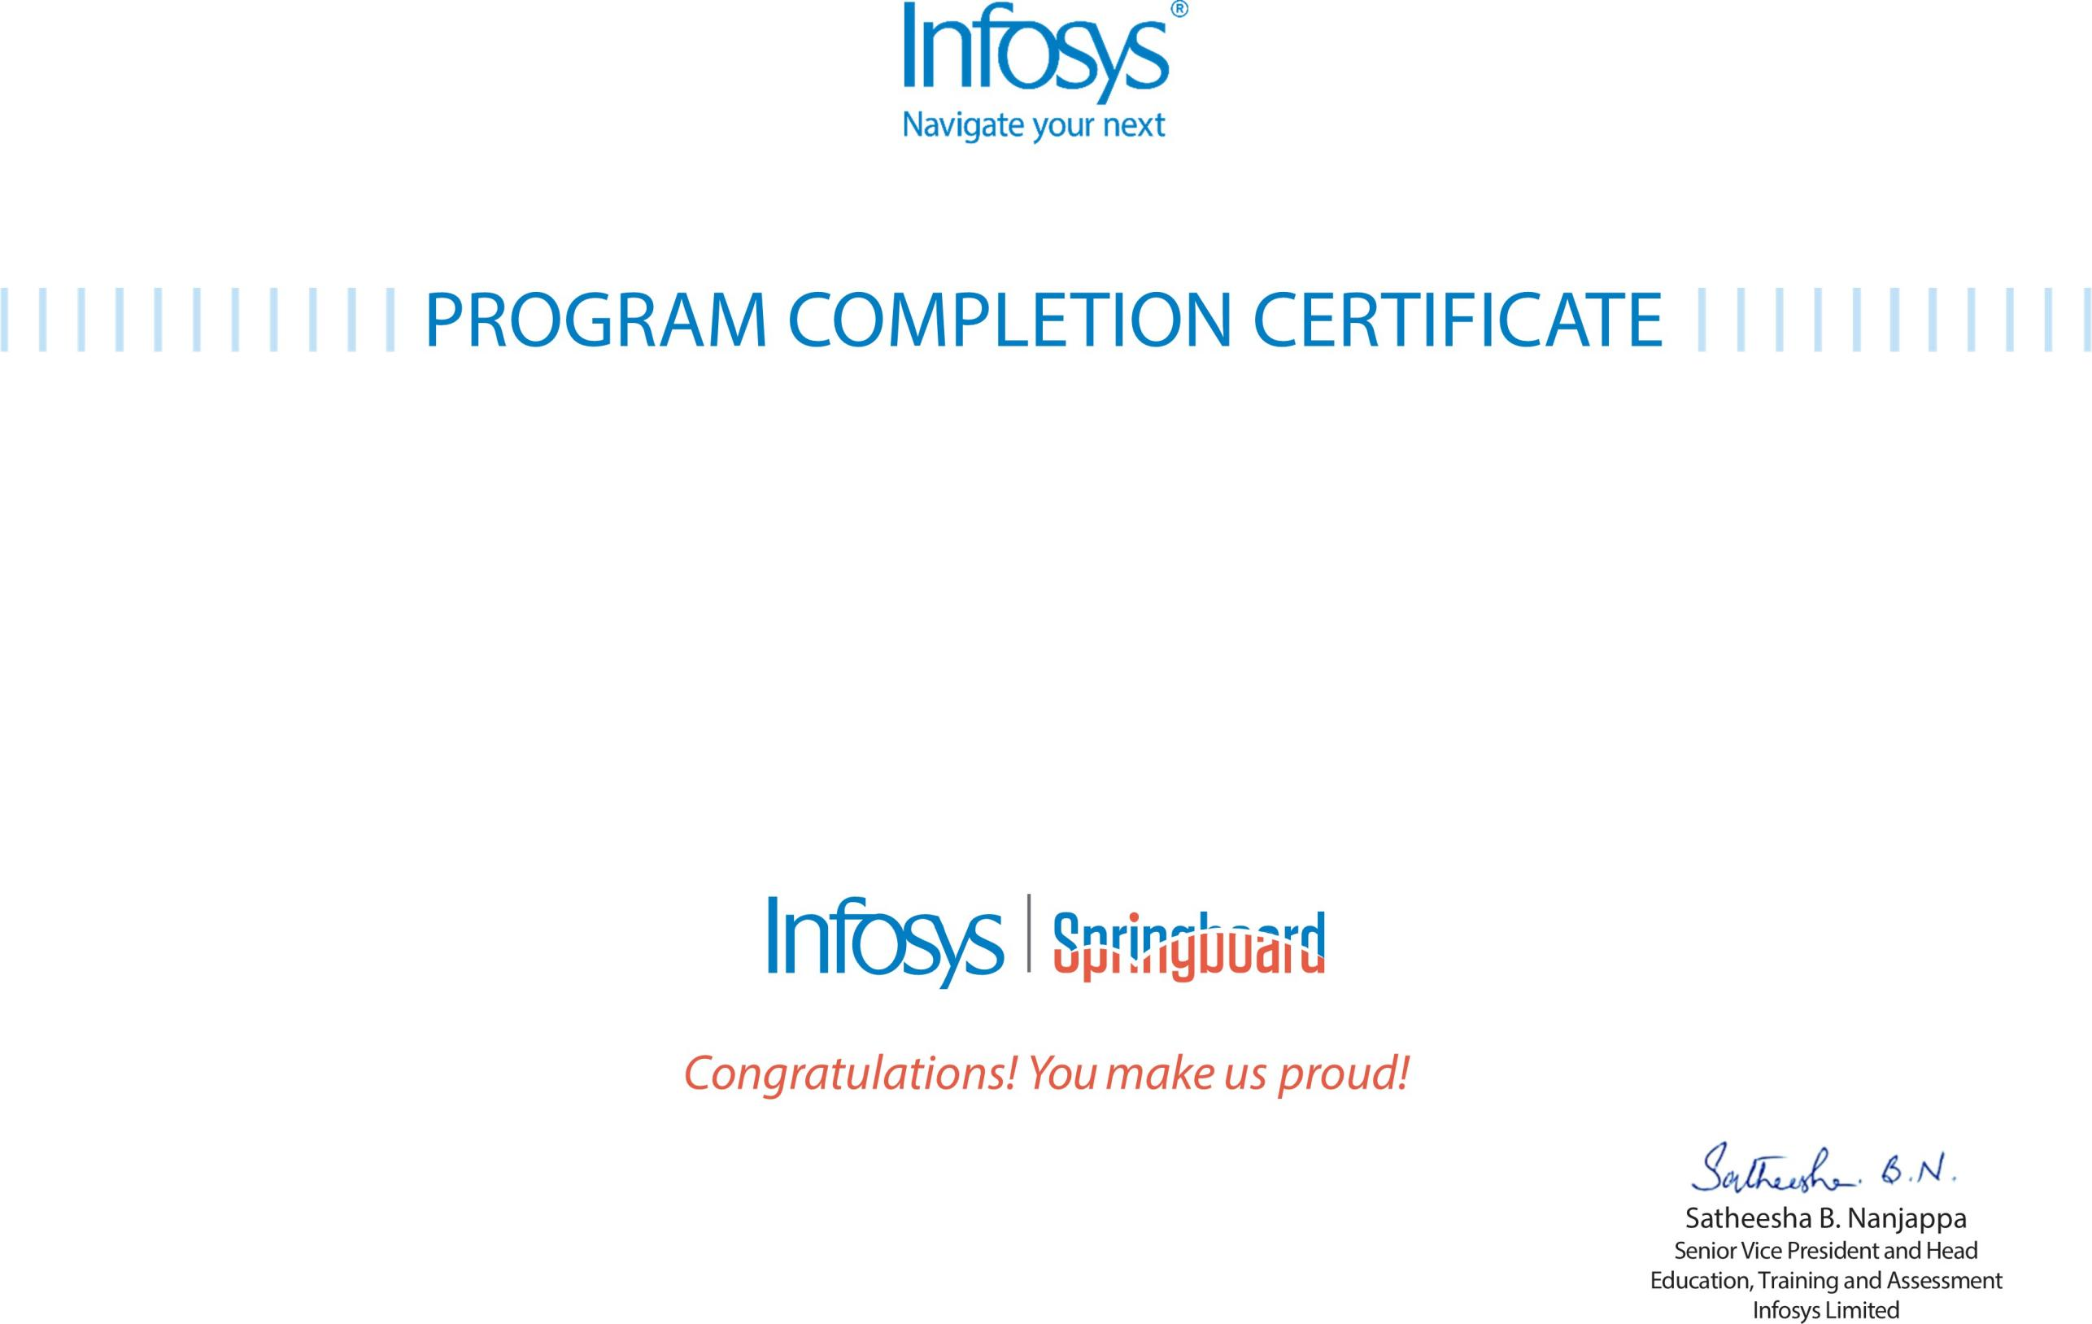
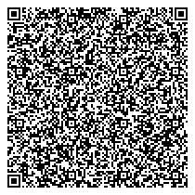

The certificate is awarded to

Devulapalli Chinmayi

for successfully completing the program
ADVANCE LEARNING PRACTICE

on January 30, 2026

Issued on: FRIDAY, January 30, 2026
To verify, scan the QR code at https://verify .onwingspan.com

